**Project Plan and Alignment with the next 4 Tutes:**

|  |  |  |  |  |
| --- | --- | --- | --- | --- |
| **Report task** | **Deliverables** | **Github** | **When** | **Marks** |
| **Problem definition: Objectives, List of Stakeholders** | Instead of interviews, analysis of the document presented and filling in the gap with any assumptions. Any assumptions made should be stated.    In this, Stages 1 and 2 of design thinking executed | ● Use Empathy Maps and point of view of statements (POV) as a preparation to create the *backlog*. We want to see everybody on the team involved [will be tracked via the timeline of commits]. | Week 1 | **6** |
| **Your Design Thinking approach to address the problem with artefacts** | Ideation using the above, i.e. using Stages 1 and 2 of the design thinking process.    200-300 word reflections and brainstormed ideas; stating any assumptions made.    Prioritised *backlog* | ● Include a reflection (text) that also describes any assumptions you made that was not made explicit in the assignment description. Include your use of POV statements to develop How Might We (HMW) statements.  ● Create a *blacklog.* This needs to be prioritized.  ● The backlog is created and this needs to be managed using issues in Github i.e., issues are progressively “closed” as the project gets done. The commit that closes each issue should be clearly stated.    ● Meaningful commits from every student each week. Interleaving of commits is expected.  ● Commits should identify when this part of the report was added to or modified in the markdown file. | Week 2 | **6** |
| **Workproducts, models and descriptions.** | Prototyping and models    Iteratively complete:    - Use case diagrams  - Activity diagrams  - Class diagrams  - Collaborative Diagrams | ● Issues get removed as their corresponding models are added to the markdown file [use cases are developed from the backlog (1 to 3 or 4) user stories can be used to create a use case. The use cases are then used to create activity diagrams. These are then used to create class diagrams and collaboration diagrams.  ● Commits should identify when this part of the report was added to or modified in the markdown file | Weeks 3-4 | **12** |
| **Competitive advantages and possible effects if the project fails** | E.g. Potential benefits to the call center (in terms of reducing cost and being able to carry out more effective calls).    - Around 500 words |  | Week 4 | **4** |
| **Using Github to role-play agile methodologies** | Explanation and outline of Scrum activities used | Recording the intention, rationale, and focus of each system’s development iteration using commit messages, project boards, and issue tracking (opening/closing) capabilities | Weeks 1-4 | **7** |
|  |  |  | **TOTAL** | **35** |

**Problem definition: Objectives, List of Stakeholders**

**Problem Definition:**

The Relationship Managers (RMs) for a major travel company perform sales of holiday packages for their customers. However, the system operation is complicated by the varying number and nature of these holiday packages. Call routing and flow control are also not adjusted to RMs skills and customers profiles, making the sales process of holiday packages inefficient.

**Objectives:**

* Develop an information system to improve the operation of the major travel company’s in-house call management centre (CMC).
* For the outbound calls, the system will create a target list for each RM based on their skills and profile.
* For inbound calls, the system will connect end-customers to RMs through matching techniques.
* Increase the sales of holiday packages
* Increase customer satisfaction
* Increase RMs satisfaction

**Stakeholders:**

* Travel Company Owner
* Relationship Managers
* Inbound End-customers (Customers who call the travel company )
* Outbound End-customers (Customers that the Relationship managers call)

**POV statement for each stakeholder**

Person [needs] _____ [because] ____

**Travel Company Owner**

POV: The travel company owner is missing out on increasing his company’s profits, due to having an inefficient system for connecting his RMS to potential customers.

HMW: Develop an information system to improve the operation of their in-house call management centre.

**Relationship Managers**

POV: RMs, who are potentially missing sales opportunities, need to speak to the most suitable customers, because they will be more likely to make a sale.

HMW: HMW improve the process for RMs to connect with more appropriate potential customers

**Inbound End-customers**

POV: Inbound end-customers, calling the travel company, are speaking to relationship managers, who are not the most suitable for satisfying their needs.

HMW: HMW match customers to the most suitable relationship managers

HMW: HMW reduce waiting times or delays for inbound customers

**Outbound End-Customers**

**POV:**

Outbound end-customers are receiving calls from RMS, who are suggesting them to purchase holiday packages that they have no interest in buying.

HMW: Direct calls from relationship managers to customers who are more likely to want to purchase holiday packages

HMW: HMW match appropriate Rms with the right skill-sets to outbound end-customers

**Empathy Map for each stakeholder:**

**Travel Company Owner-**

**1.Owner, He wants to make changes in the system, he wants the sale in the holiday packages to increase, he is the decision-maker or can implement the changes in the system.**

**2. If the sales increase we can know he was successful, he needs to know what the customers say and make the changes accordingly.**

**3. They can see their own package sale and compare it with their competitors, they can train the managers with the new program.**

**4.make advertisement to promote the system.**

**5.**

**6. They hear the benefits from using the new system and also hear issues and problems they can face.**

**7. Pain- The investment will be a total loss, it will take time to get familiar with the system**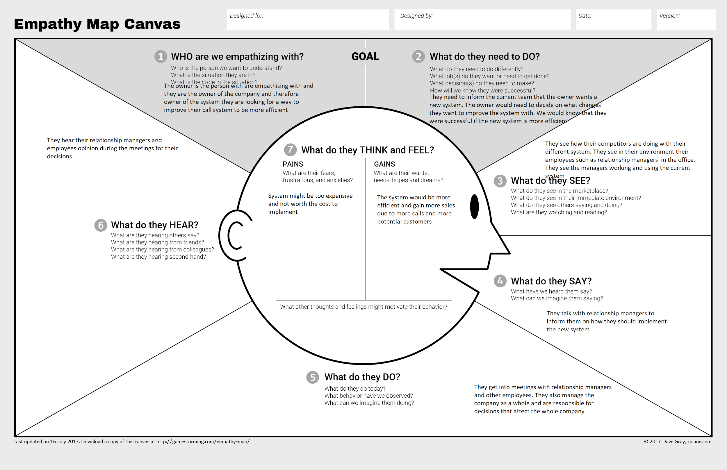

**https://imgur.com/a/WeYDk3y**

**Gains- Better value, more sales**

**Relationship managers**

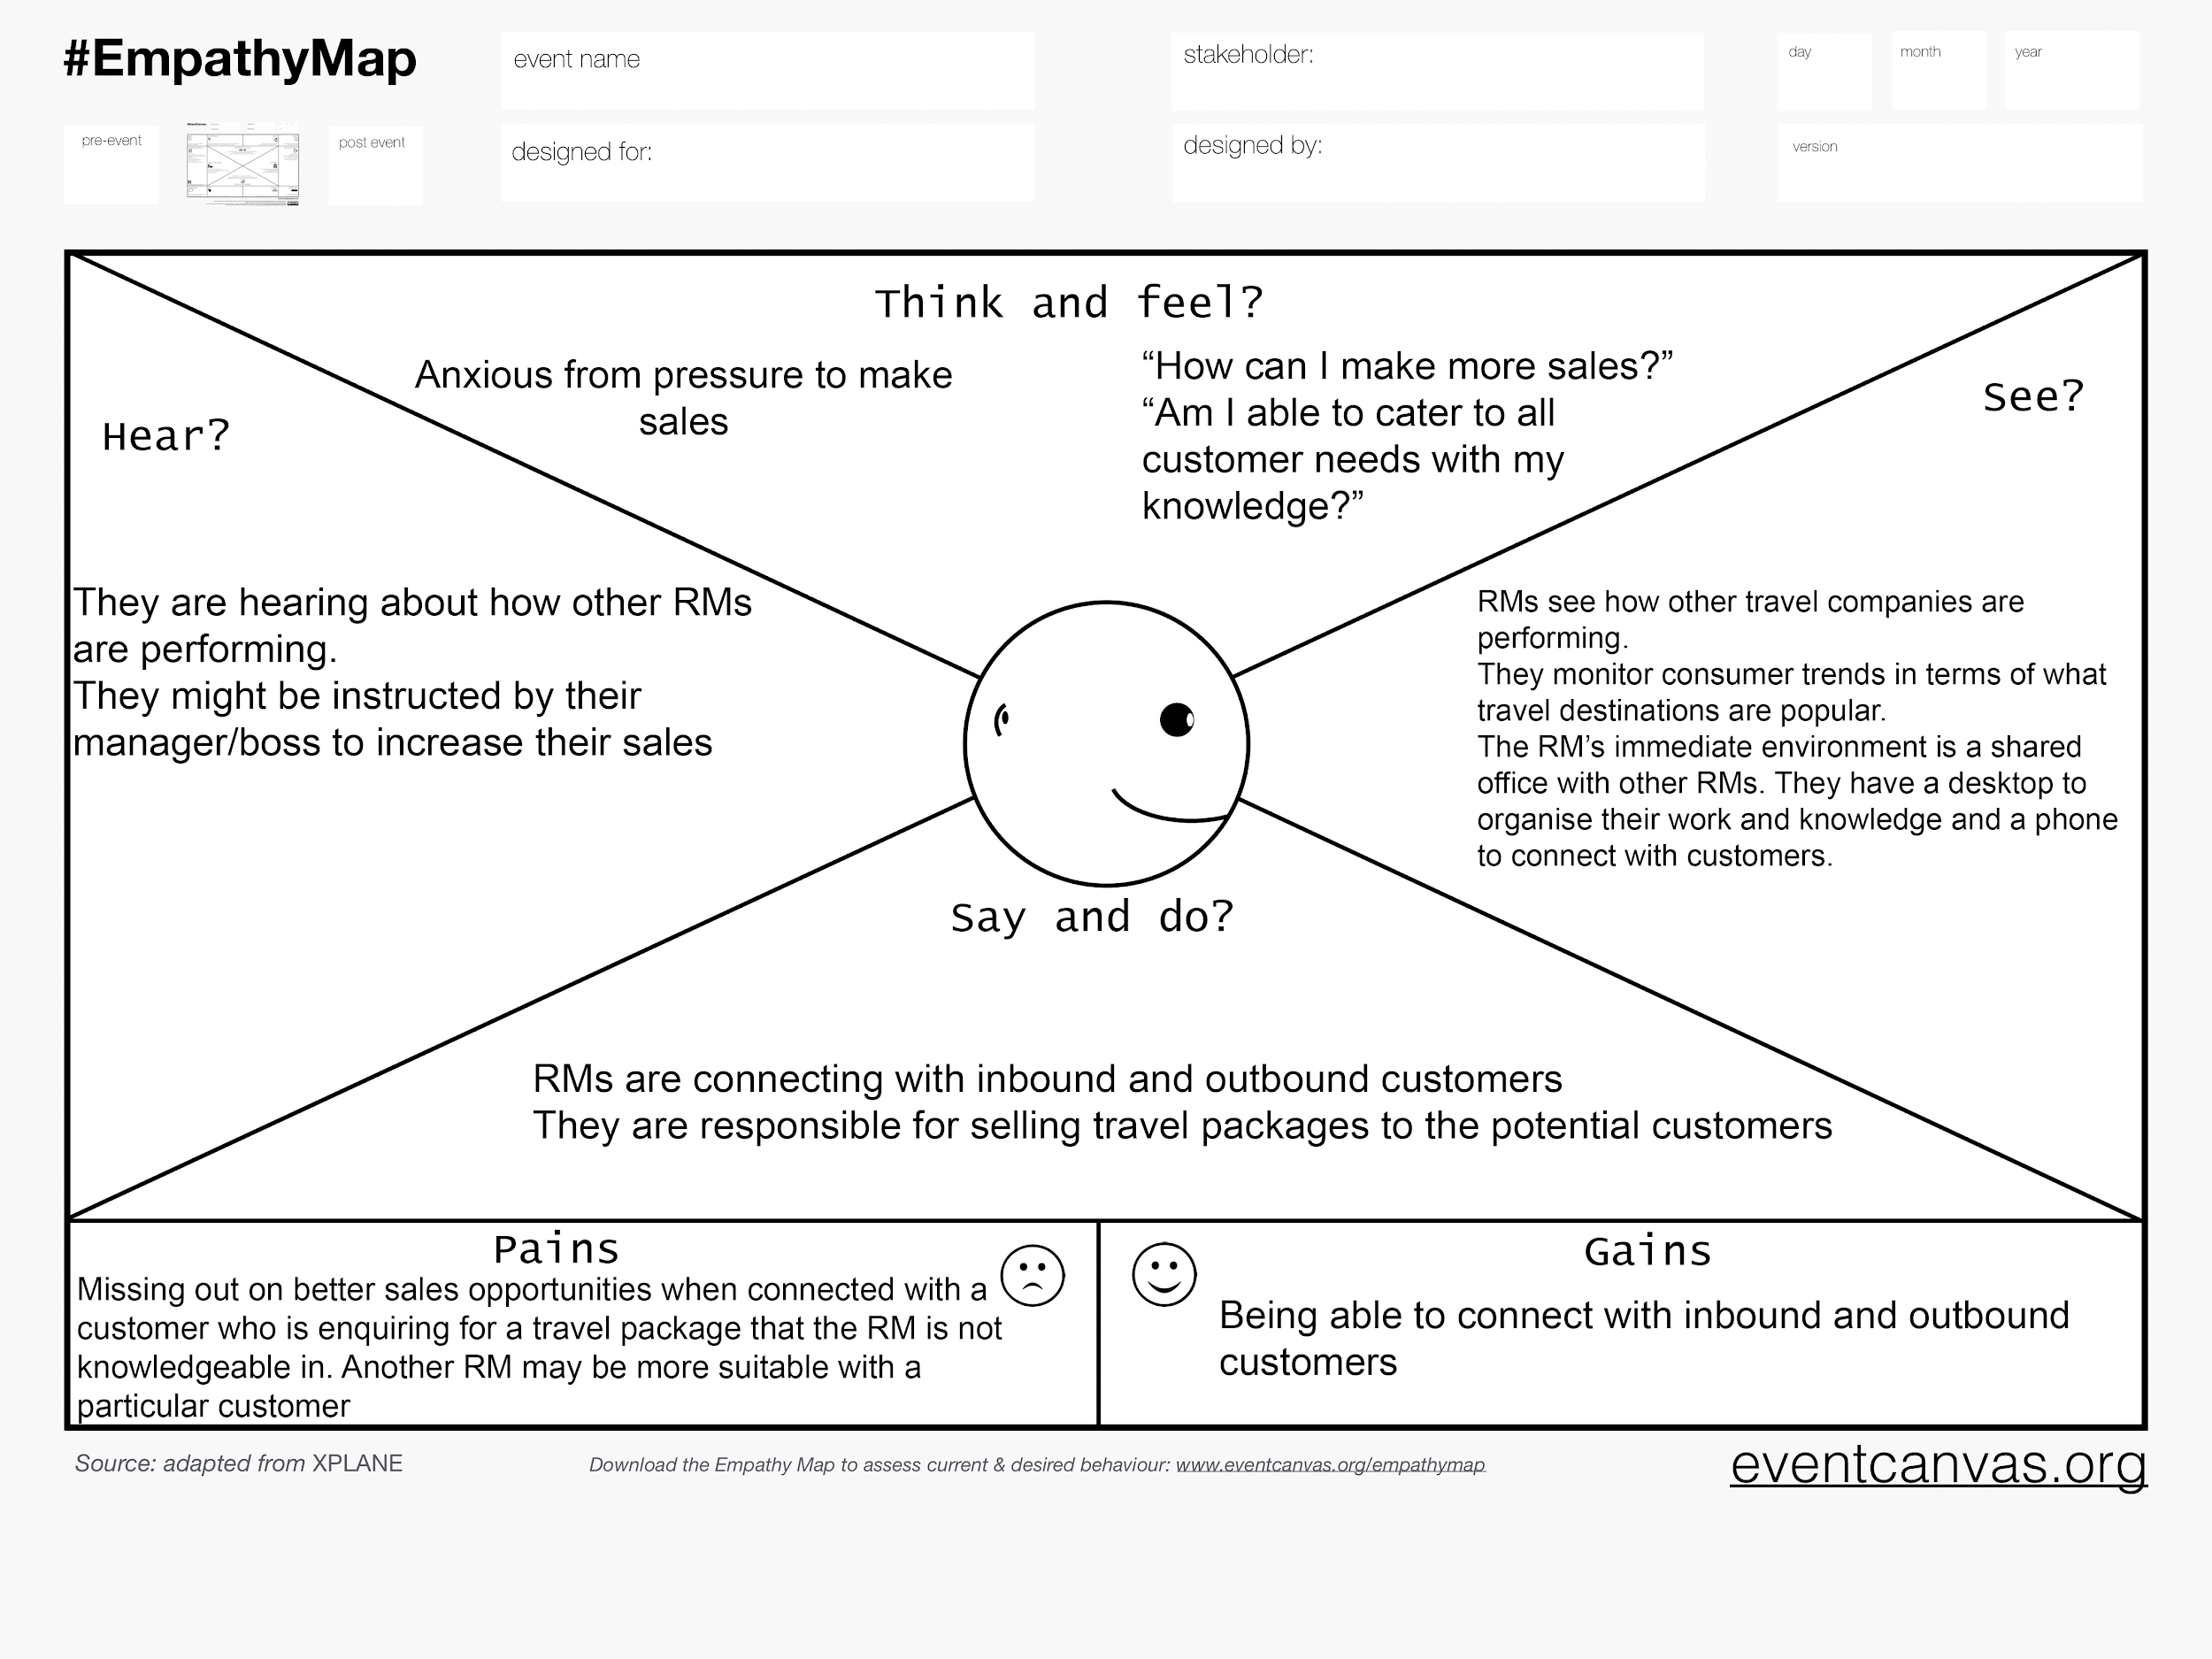

**Inbound Customer**

Think and Feel

* Where should I go for my next holiday?
* Which travel company should I call to purchase a holiday package?
* Will I be speaking to someone who is professional and will help fulfil my needs?

See

* They can see advertisements from the travel company regarding holiday packages

Say & Do

* Inbound customers call the travel company in the hopes of finding the best deal for a holiday packages
* Depending on the service they receive, they can have a positive or negative attitude towards the travel company
* Depending on the service they receive, they can relay their calling experience to their friends and family as either nice or unpleasant

Hear

* Inbound customers will be able to hear RMs try to cater to their needs and offer various holiday packages
* They can hear feedback from friends and family who have dealt with the travel company before

Pain

* It is possible for Inbound customers to speak to a RM who is not well suited to cater to their needs
* They can feel that their time was wasted
* They can feel like they wished to have spoken to a different RM or to have called a different travel company
* They can be anxious about not having their desired holiday

Gain

* Being able to speak to a suitable and professional RM to help them with their needs
* Finding a good value deal on a holiday package
* To be able to have a fun and exciting holiday

**Outbound Customer**

Think & Feel

* Do I want to purchase a holiday package?
* Are their better deals for holiday packages from other companies?

See

* Outbound customers are able to see advertisements for holiday packages from various travel companies

Say & Do

* Outbound customers receive calls from Rms in regards to holiday packages
* Depending on the Rms convincing skills and the needs of the customer, outbound customers may or may not purchase a holiday package
* Depending on the outcome of the call, outbound customers can have a favourable or unfavourable attitude towards the travel company

Hear

* Outbound customers will be able to hear RMs try to convince them on buying a holiday package
* They will be able to hear either positive or negative feedback from friends and family who have previously dealt with the travel company

Pain

* Outbound customers can have no interest in purchasing holiday packages and be annoyed by calls from RMs
* Outbound customers can feel that they can find better value on holiday packages elsewhere or with another company
* They can feel like the calls are spam

Gain

* They are able to receive a good deal on a holiday package

**Backlog**

Functional Requirements

* The system shall adjust the call flow rate to suitable RMs
* The system shall match Rms and end-customers according to Rms skills and customer profiles
* The system shall match customers based on RM performance and product knowledge
* The system shall build a profile and skill matrix
* The system shall adjust according to RMs subsequent performance in selling packages and in serving customers effectively and efficiently.
* The system shall dial numbers automatically according to a customer target list generated by the system
* The system shall retrieve customers details from a database
* The system shall display the details and provides the RM with guidelines and a script to help in providing an improved service to the end-customer
* For the outbound calls, the system shall create a target list for each RM based on their skills and profile.
* For inbound calls, the system shall use a call routing and distribution routine to minimise inbound call costs.
* The system shall calculate a skill score based on the RM’s previous call duration and profile
* The system shall use preloaded customer data to score inbound customers out of 10 based on their likelihood to purchase the product.
* The system shall connect customers with the highest scores first with RMs
* During busy times, the system shall direct inbound customers to an Interactive Voice Response unit prompting them for options, and ask for call reasons in a few words and then redirect the call to an Automatic Call Distributor routing the call to the first available appropriate RM

Non-functional Requirements

* The user interface for RMs shall be simple to use and easy to navigate through
* Information that is entered by the RM shall be stored on a secured server
* Navigating through customer profile pages shall load a display within 5 seconds at least 97% of the time
* Every unsuccessful attempt by a RM to login to the system shall be recorded and after a third failed attempt the RM will be locked out from the system and will not be able to log in for another 3 hours.

As a <role>,

I want <goal/desire>

so that <benefit>

* [As a Travel Company Owner] [I want the sales of holiday packages to increase] [So that the company’s profits will increase]
* [As a relationship manager] [I want improved call routing and dynamic call flow control for inbound and outbound calls] [So that I can increase sales of holiday packages]
* [As an end-customer] (inbound)[I want to speak to the most suitable RMs] [So that I can conveniently find the best value holiday package]
* [As an end-customer (outbound)] [I want to speak to the most suitable RMs] [So that I can have improved customer service]
* BACKLOG section
* [As a relationship manager] [I want to connect with the most suitable customer][So that I can effectively meet the needs of the customer and make a sale]
* [As an inbound customer][I want to connect to an RM as fast as possible][So that I can be served promptly]

As a Travel Company Owner I want a more efficient system because the current system is inefficient so that i can can get more sales

As a Relationship Managers I want a more efficient call system because the current system is slow and inefficient and it allows for more targeted calls to customers so that i can increase sales

# Reflection